**Computer Hardware**

**Class Five**

**Lab 1**

|  |
| --- |
| Lab Objectives:  * **Processor – ALU** * **Controller** * **Register** * **Motherboard** |

# Overview of a Computer:

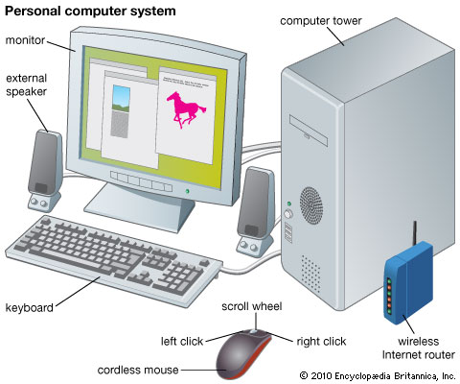

# Processor

## A processor, or "microprocessor," is a small chip that resides in [computers](https://techterms.com/definition/computer) and other electronic devices.

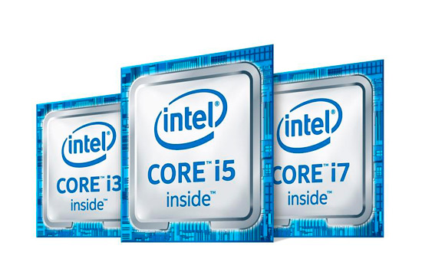

## Its basic job is to receive [input](https://techterms.com/definition/input) and provide the appropriate [output](https://techterms.com/definition/output). While this may seem like a simple task, modern processors can handle trillions of calculations per second.

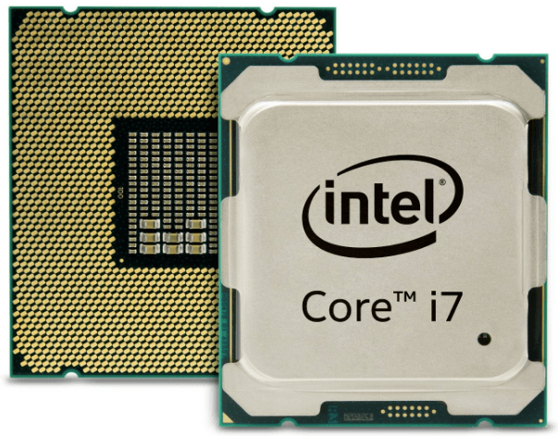

# Computer Architecture

## Computer architecture is a specification detailing how a set of software and hardware technology standards interact to form a computer system or platform

## IMG_256

## In short, computer architecture refers to how a computer system is designed and what technologies it is compatible with.

# Arithmetic Logic Unit (ALU)

## An arithmetic logic unit (ALU) is a major component of the central processing unit of a computer system.

## IMG_256

## It does all processes related to arithmetic and logic operations that need to be done on instruction words.

# Control Unit

## Control Unit is the part of the computer’s central processing unit (CPU), which directs the operation of the processor.

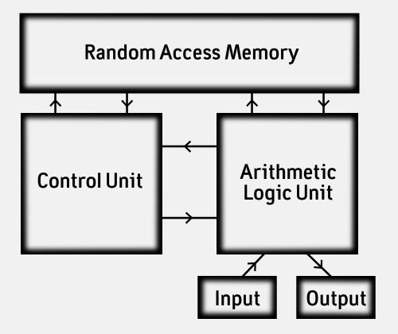

# Registers

## Register is a very fast computer memory, used to store data/instruction in-execution.

## Register may hold:

## A computer instruction

## A storage address

## Or any kind of data

# Symbol, Name and Function

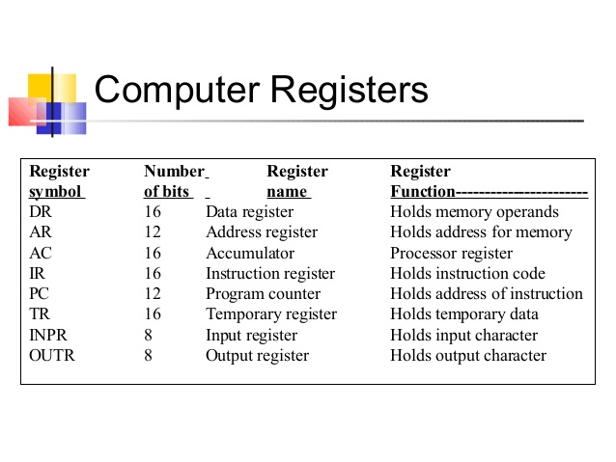

# Motherboard

## A motherboard is one of the most essential parts of a computer system.

## It holds together many of the crucial components of a computer, including the central processing unit (CPU), memory and connectors for input and output devices.

